Enhanced Interaction of Ciprofloxacin with Humic Substances and Magnetite-Silica-Nanoparticles in Multicomponent System: Spectrophotometric and Electrokinetic Studies

- Equilibrium Sorption Studies
Table S1 Cipher, description and pH of solutions.
Cipher of sample | Description of sample | pH of solution
HP0.01 | Humic preparation, concentration − 0.01 g·L⁻¹ | 6.59
HP0.05 | Humic preparation, concentration − 0.05 g·L⁻¹ | 6.55
CIP | Solution of ciprofloxacin (5 mg·L⁻¹) | 7.22
MTA1 | NPs of magnetite modified by TA, concentration is 1 g·L⁻¹ | 6.66
MTA2 | NPs of magnetite modified by TA, concentration is 2 g·L⁻¹ | 6.72
CIP-HP-0.01 | Suspension of CIP (5 mg·L⁻¹) with HP and MTA (1 g·L⁻¹) | 6.79
CIP-HP-0.05 | Suspension of CIP (5 mg·L⁻¹) with HP (0.05 g·L⁻¹) | 6.62
CIP- MTA-1 | Suspension of CIP and MTA (1 g·L⁻¹) | 6.49
CIP- MTA-2 | Suspension of CIP and MTA (2 g·L⁻¹) | 6.62
СIP-HP0.01-MTA1-6 | Suspension of CIP with HP (0.01 g·L⁻¹) and MTA (1 g·L⁻¹) | 7.04
СIP-HP0.05- MTA1-6 | Suspension of CIP with HP (0.05 g·L⁻¹) and MTA (1 g·L⁻¹) | 6.61
СIP-HP0.01- MTA1-8 | Suspension of CIP with HP (0.01 g·L⁻¹) and MTA (1 g·L⁻¹) | 6.91
СIP-HP0.01- MTA2-8 | Suspension of CIP with HP (0.01 g·L⁻¹) and MTA (2 g·L⁻¹) | 6.85
СIP-HP0.05- MTA2-8 | Suspension of CIP with HP (0.05 g·L⁻¹) and MTA (2 g·L⁻¹) | 6.95

- Calibration Curves for the Determination of Ciprofloxacin (CIP) in Water at
Different pH Values
The proportionality of the dependence of the area S of the antibiotic absorption band on the concentration of CIP (C) (Fig. S1) allows it to be used to determine the concentration of CIP in water at different pH values. The general formula for determining the concentration C will be as follows: C = K∙S, where K=1/k is an empirical coefficient depending on the pH of the medium.
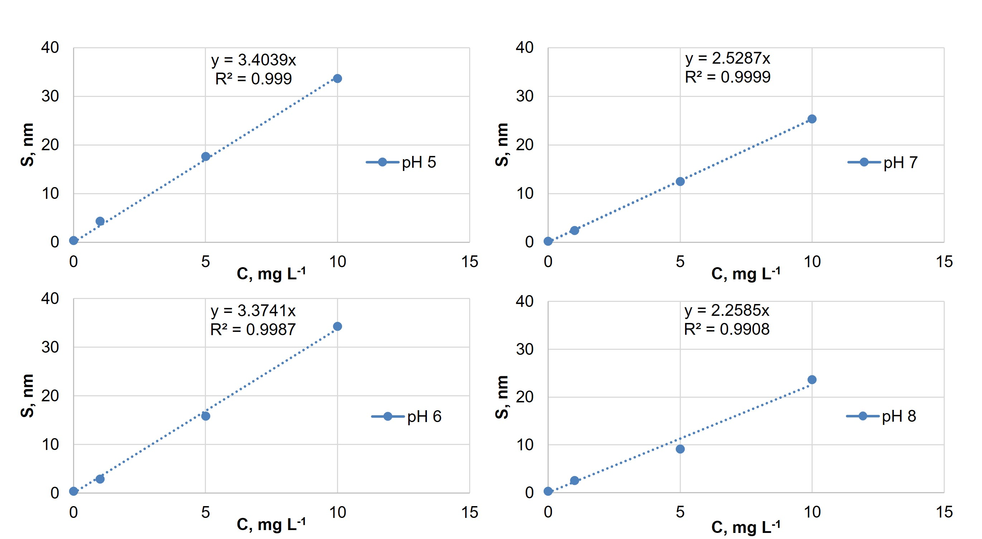

Fig. S1 Calibration dependences of the CIP absorption band area versus CIP concentration at various pH.
- Absorption Spectra of Humic Preparation (HP) and Mixtures of CIP and HP in Water
It has been hypothesized that the absorption spectrum of the antibiotic together with HP is a superposition of their individual absorption spectra (Fig. S2). To do this, the HP absorption band was subtracted from the absorption spectrum of the multicomponent solution (Fig. S3), as a result of which the initial spectrum was obtained, corresponding to the absorption of pure CIP in distilled water.
CIP can thus exist as a cation, anion and zwitterion as seen in Fig. S5.

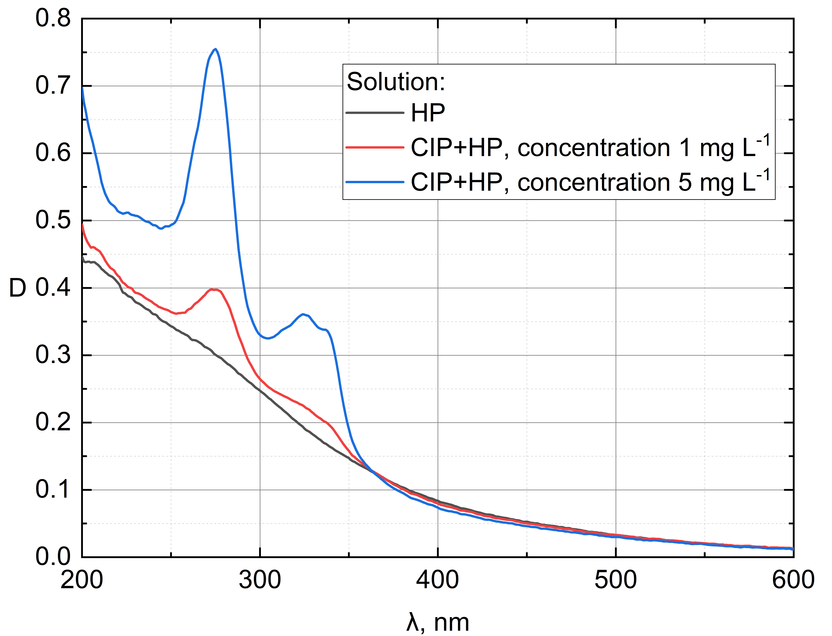
Fig. S2 UV-Vis spectra of a multicomponent CIP and HP solutions.

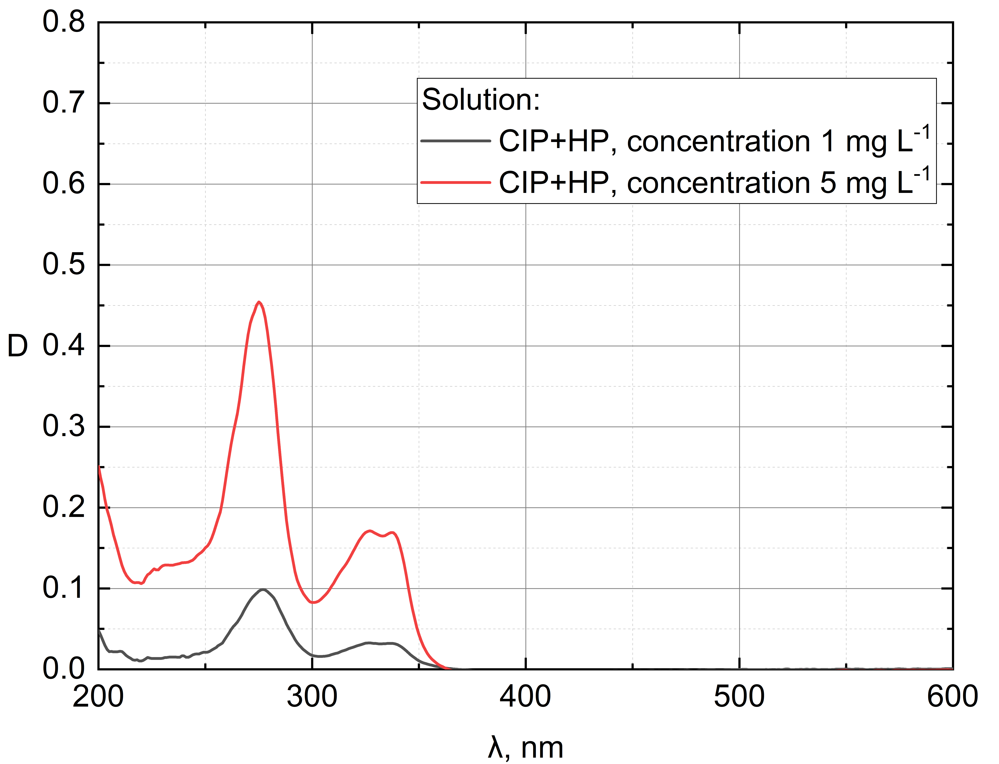
Fig. S3 Absorption spectrum of CIP obtained by subtracting the absorption band of a HP from the absorption spectrum of a multicomponent solution.
- Influence of pH and Dissolved Organic Matter
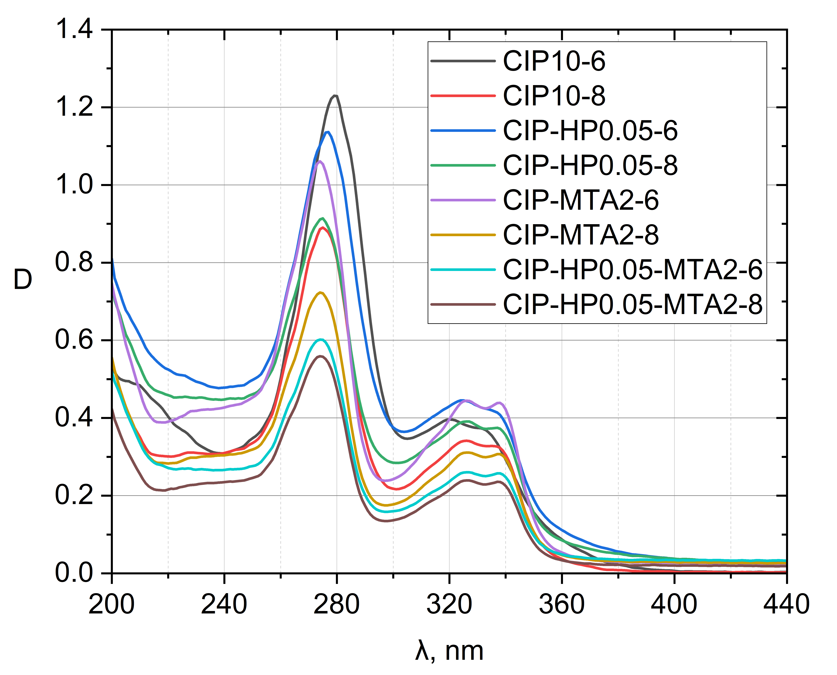
Fig. S4 Absorption spectra of CIP at different concentrations in water with the addition of HP at a concentration of
50 mg·L⁻¹. Absorption of HP was subtracted from the spectrum of the (CIP + HP).
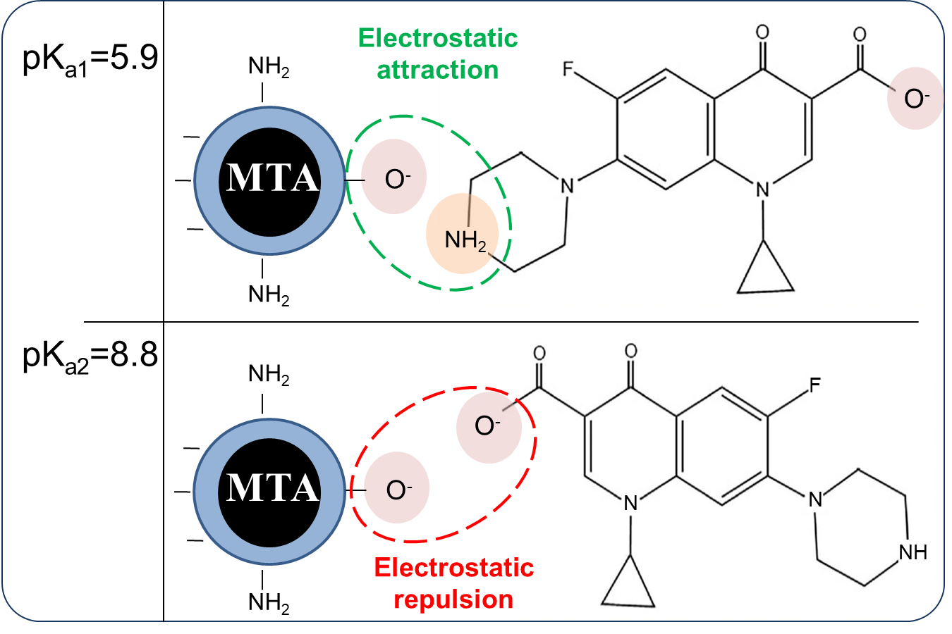
Fig. S5 The proposed mechanism for interaction between CIP and MTA (modernized from Ref. [1])
- Scanning and Transmission Electron Microscopy (SEM and TEM)
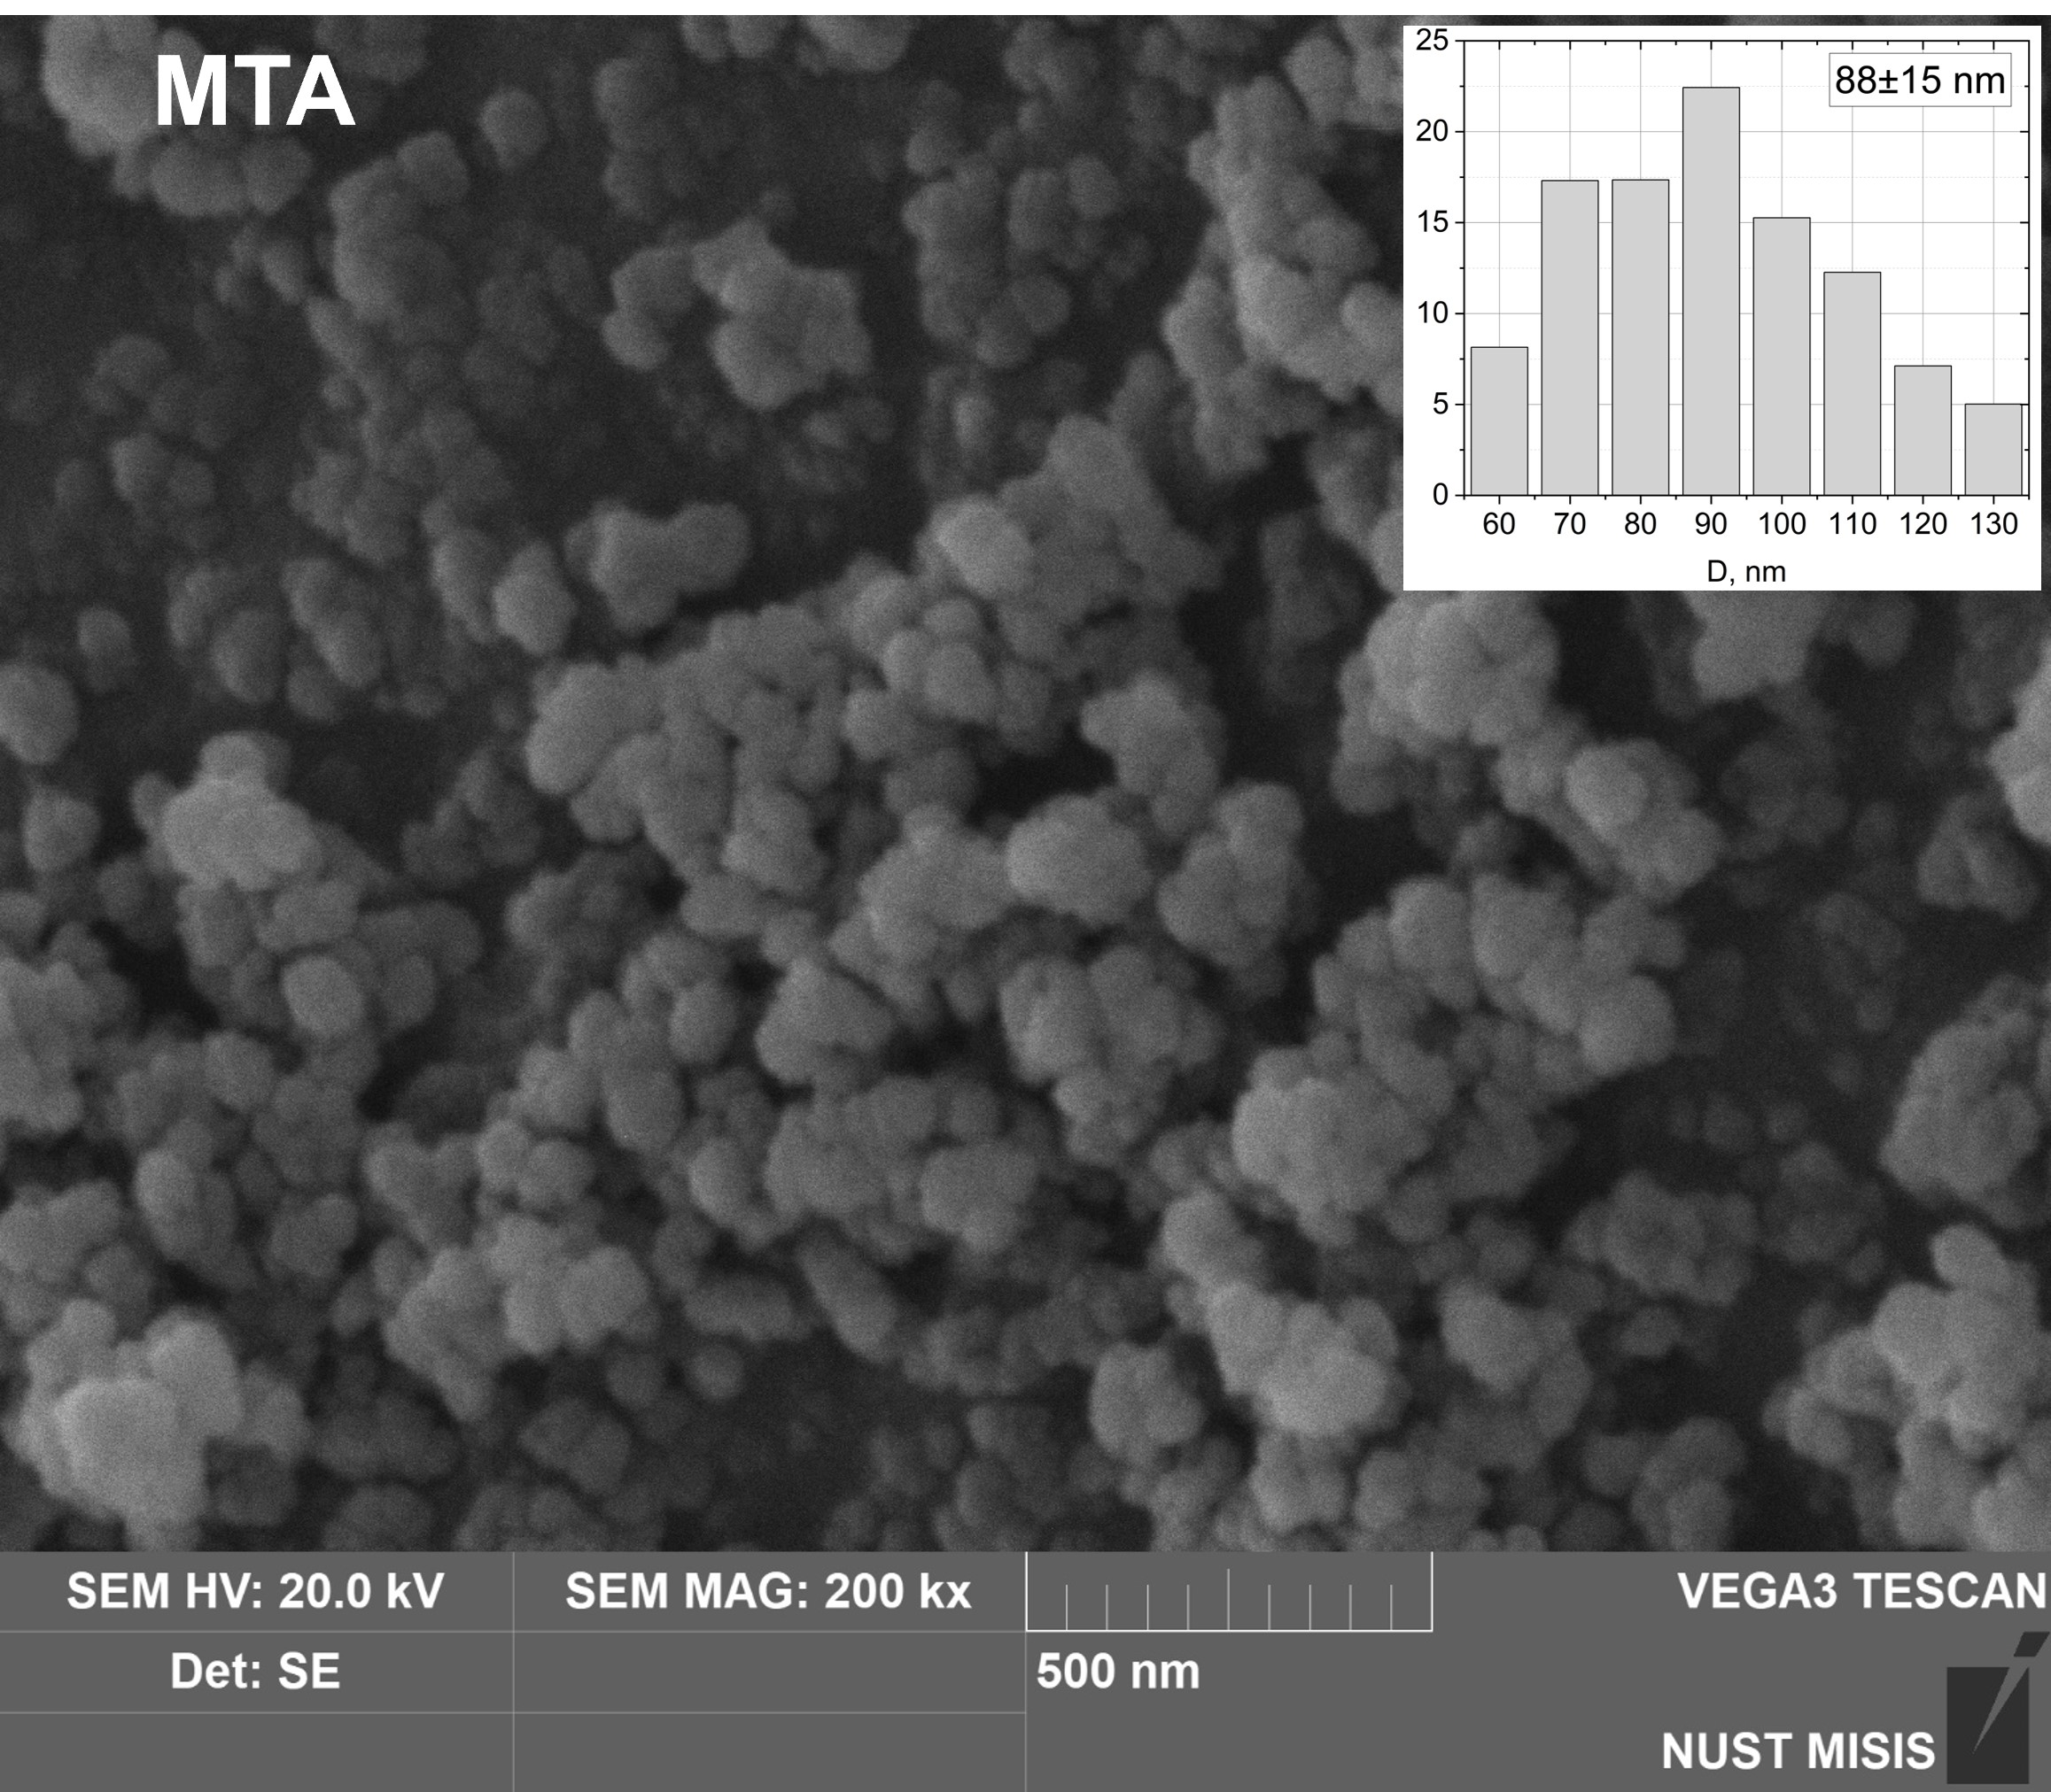 | 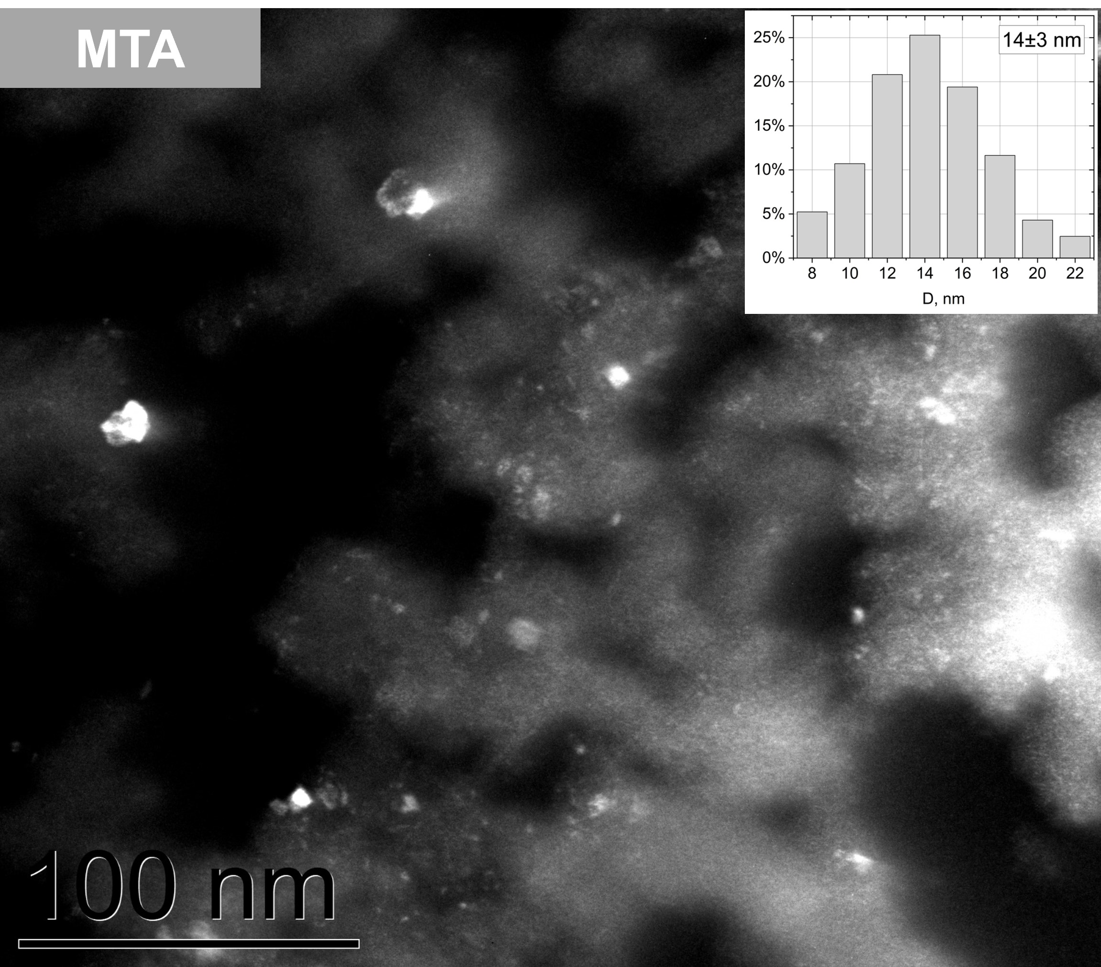
(a) | (b)
Fig. S6 (a) SEM and (b) TEM microphotographs with size distribution histograms of MTA.

References
- H. Rasoulzadeh, A. Mohseni-Bandpei, M. Hosseini, and M. Safari, “Mechanistic investigation of ciprofloxacin recovery by magnetite–imprinted chitosan nanocomposite: Isotherm, kinetic, thermodynamic and reusability studies,” International Journal of Biological Macromolecules 133, 712−721 (2019).

